NAME: VISHWAS M

SRN: PES2UG20CS390

SECTION: F

WEEK: 1

SUB: MPCA LAB

1. mov.s

CODE:

mov r1,#26

mov r2,#70

SCREENSHOT:

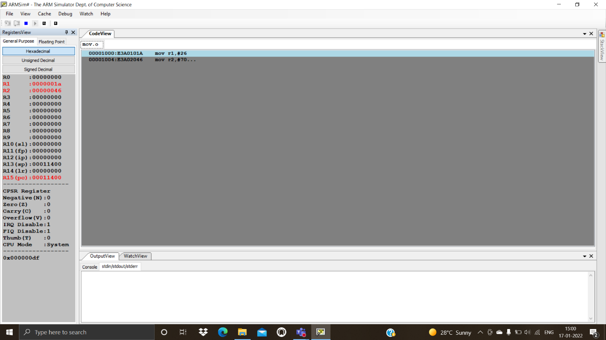

1. add.s

CODE:

mov r0,#13

mov r1,#8

add r2,r1,r0

SCREENSHOT:

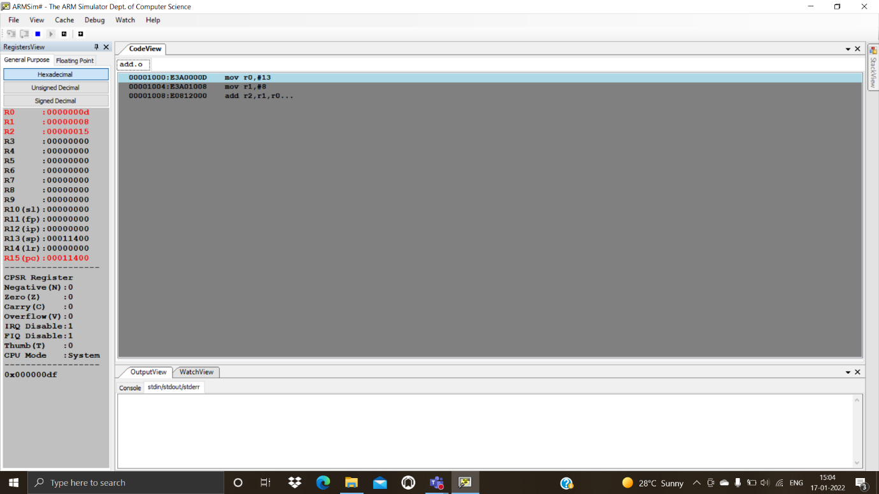

1. sub.s

CODE:

mov r0,#19

mov r1,#6

sub r2,r0,r1

SCREENSHOT:

